Project Design Phase-II Technology Stack (Architecture & Stack)

Date | 31 January 3035
NM ID | 8050612605B5D909A0D43F9BC95E1D9A
Project Name | Garage Management system
Maximum Marks | 4 Marks

Technical Architecture:
The Deliverable shall include the architectural diagram as below and the information as per the table1 & table 2
Example: Order processing during pandemics for offline mode
Reference: https://developer.ibm.com/patterns/ai-powered-backend-system-for-order-processing-during-pandemics/
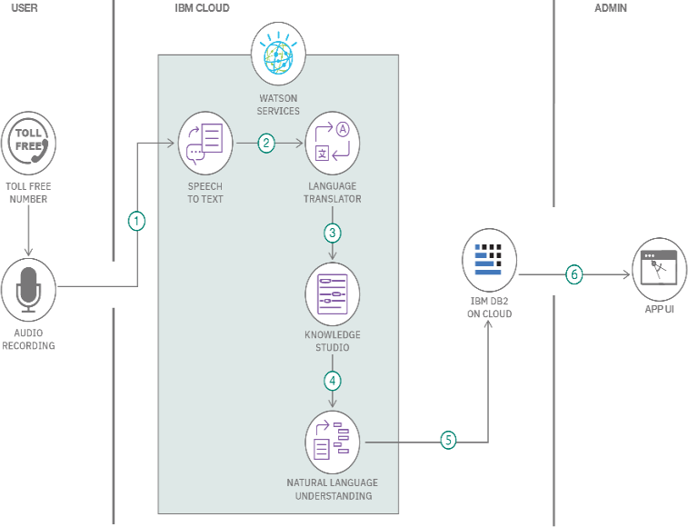
Guidelines:
Include all the processes (As an application logic / Technology Block)
Provide infrastructural demarcation (Local / Cloud) Indicate external interfaces (third party API’s etc.) Indicate Data Storage components / services Indicate interface to machine learning models (if applicable)

Table-1 : Components & Technologies:

S.No | Component | Description | Technology
1. | User Interface | Admin interacts via Web dashboard in ServiceNow. | ServiceNow Web UI
2. | Application Logic-1 | Checks if user is linked to an incident before allowing deletion | ServiceNow Flow Designer, Script
3. | Application Logic-2 | Validates user status from incident table | GlideRecord in Server Script
4. | Application Logic-3 | Sends notification if deletion is blocked. | ServiceNow Notifications
5. | Database | Stores user, incident, and assignment data | ServiceNow CMDB, Incident Tables
6. | Cloud Database | Managed by ServiceNow cloud backend. | ServiceNow Cloud Database
7. | File Storage | Minimal use; logs stored internally | ServiceNow system logs
8. | External API-1 | (Optional) HRMS integration to verify user status | REST API in ServiceNow
9. | External API-2 | Not applicable | -
10. | Machine Learning Model | Not applicable for current use case | -
11. | Infrastructure (Server / Cloud) | Hosted and managed on ServiceNow SaaS platform | ServiceNow Cloud (SaaS)

Table-2: Application Characteristics:

S.No | Characteristics | Description | Technology
1. | Open-Source Frameworks | Not applicable (ServiceNow is proprietary) | -
2. | Security Implementations | Role-based access control, ACLs, secure scripts | ACLs, Scoped Applications
3. | Scalable Architecture | SaaS-based, horizontally scalable via ServiceNow architecture | ServiceNow Cloud Architecture
4. | Availability | Highly available with ServiceNow cloud hosting | Load-balanced ServiceNow Instances
5. | Performance | Optimized via asynchronous flows and indexed tables | GlideRecord, Background Scripts

